FAZAIA BILQUIS COLLEGE OF EDUCATION FOR
WOMEN PAF NUR KHAN, RWP

Parallel Distributed Computing (LAB)
Lab 4 Tasks
Submitted to
Ma’am Iffat

Submitted by
Javeria Fazal
BSCS 7th B
F21-62

Task 1
You are required to write a C# program that simulates the lifecycle of a thread by creating a thread that performs simple
actions (e.g., printing messages). The program should:
1. Display when the thread is created (new state).
2. Demonstrate when the thread is running.
3. Put the thread into a waiting/sleeping state for a short time.
4. Resume execution and finally move into the terminated state.
- Source Code Screenshot:
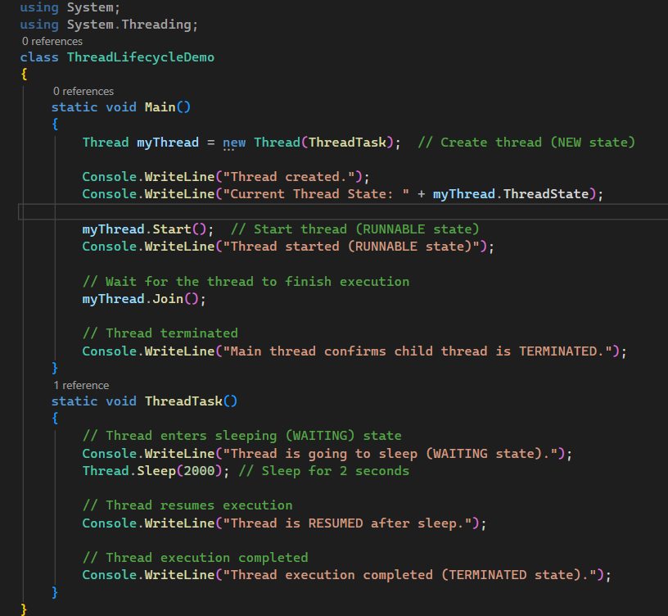
Figure 1: Thread Lifecycle
- Output Screenshot:
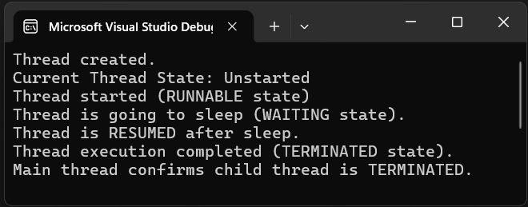
Figure 2: Output
Task 2:
You are required to write a C# program that creates two
threads:
1. A foreground thread that simulates a critical task by printing a message in a loop.
2. A background thread that simulates a non-critical task by printing a message in a loop.
the main and foreground threads finish execution.
3. The program should demonstrate how the foreground thread completes fully, while the background thread may be terminated early once the main and foreground threads finish execution.
- Source Code Screenshot:
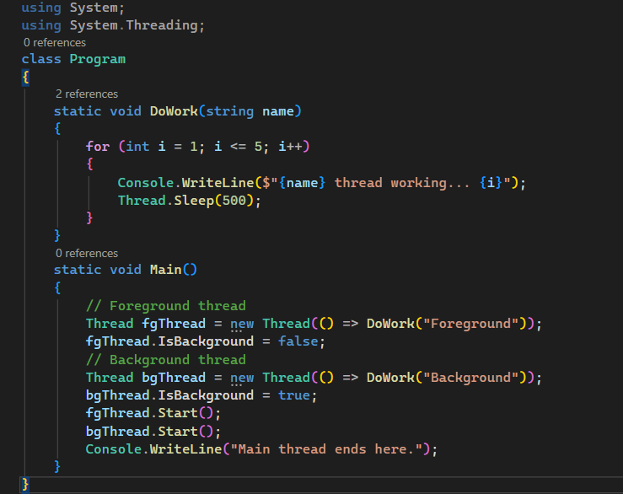
Figure 3
- Output Screenshot:
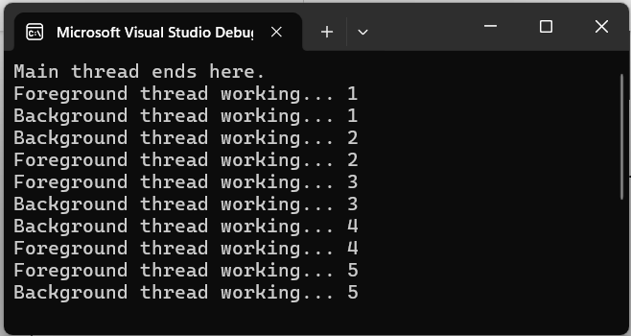
Figure 4
Task 3:
1. Find out the IP address of your machine Via ipconfig
2. Using multithreading send a message from one computer system to any other computer system in the Lab.
- Source Code with output Screenshot:

- Server side with output:

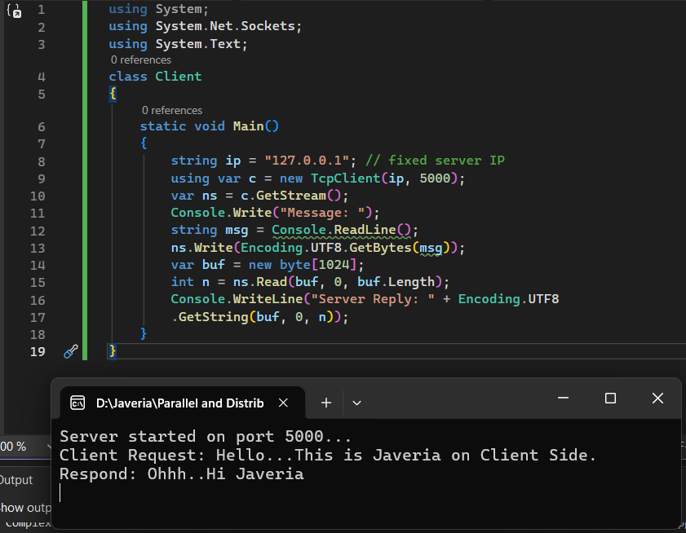
Figure 5: Source Code with Output (Client)
- Client Side with Output Screenshot:

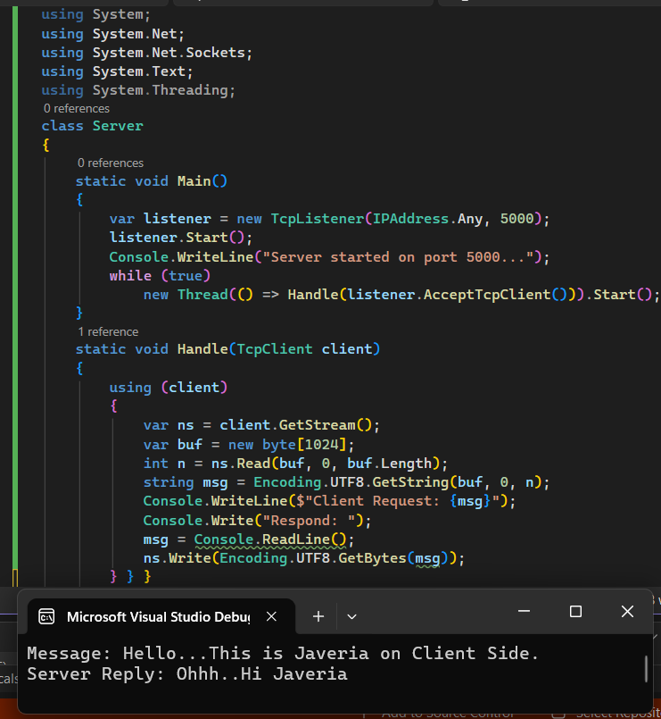
Figure 6: Source Code with output(Server)

